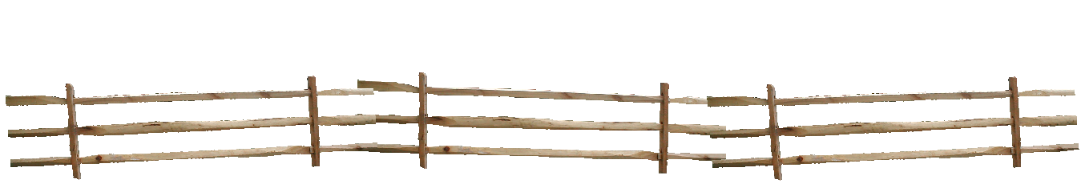


Concert on the Grass
Sunday, August 21st 4:00 – 6:00 P.M.

FREE FAMILY EVENT!

Enjoy an afternoon of Irish folk music with lively fiddle, rhythm and melody guitars, bass, percussion, and vocals by local band Rose in the Heather!

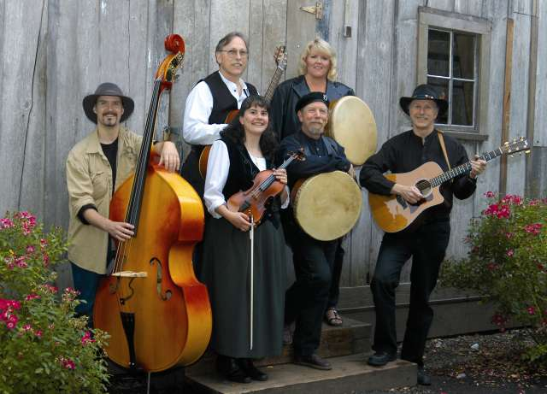
The Concert on the Grass will be held on the lawn behind the Pioneer Mothers Memorial Cabin. Bring a picnic or purchase a snack from our concession stand. Concert attendance and parking at
the Newell Pioneer Village are free; donations are appreciated to help
keep this popular event going!

Our museums – the Newell House, Pioneer Mothers Memorial Cabin, & Butteville Academy – will be open
11:00 A.M. – 3:00 P.M. Admission for
a historical tour is $6/adult, $5/senior,
AAA or DAR member; and $3/children
12 and under. Come early if you would
like a tour!

Newell Pioneer Village, 8089 Champoeg Rd. NE, St. Paul, OR
www.newellpioneervillage.com 503-678-5537 info@newellpioneervillage.com

